# Game Design Document Outline

The Game Design Document (GDD) is the blueprint from which a computer or video game is to be built. **It provides the “what” of a video game, not the “how” – that’s the Technical Design Document (TDD)**. Your GDD should have nothing related to how anything in your game will be implemented – it focuses solely on the contents of your game.

Below you will find an outline for a generic Game Design Document. The problem is that no generic GDD will be able to address all the various genres for which a game may be created. For example, consider the games Pac Man, SimCity, and Doom. All three games required detailed design documents, but if you think about it, those documents would be entirely different! As such, when using the outline below you will find sections that will be totally meaningless to your game. But also, there will be additional sections that your GDD requires to describe the game. Just because it’s not in the outline, it doesn’t mean that it doesn’t belong. You should follow the outline below, inserting and excluding sections as it fits your game. Finally, your GDD should contain images as well as text. These could be scanned sketches, screenshots, computer generated graphics, and so forth.

A game design document is meant to be a living document. Just as when the artist changes the design of his painting every time he takes his brush to the canvas, a computer or video game evolves as code and art are created. The GDD then is the communication tool from which all the members of the team can follow that evolution.

1. Title Page
   1. Game Name – Crashed
2. Game Overview
   1. Game Concept –A horror game based in a decrepit hospital where a confused soul must escape deaths clutches long enough to find out their own tragic story.
   2. Genre – Horror/Suspense
   3. Target Audience – Gamers, fans of horror, and story lovers
   4. Game Flow Summary – The player will move through the game using a mouse and keyboard. Their visual interface will be void of any extra information outside of the environment they are to explore. Movement wise, they will be able run or crouch, which will assist them in escaping or hiding from the threat they will encounter as they explore and progress. The player will progress through a hospitals main lobby, which will act as the introduction area, various floors moving up the building, where they will need to evade their pursuer, and the final floor, where they will reach their goal.
   5. Look and Feel –The look and feel of this game will ideally convey a foreboding, malevolent, or isolated atmosphere. Visually the game will be based in decaying hospital, which will enhance the previously stated feelings.
3. Gameplay and Mechanics
   1. Gameplay
      1. Game Progression – Progression will be based on the ascension of levels within the hospital environment, which will be triggered once the player reaches the exit area of each visited level.
      2. Mission/challenge Structure – The player’s goal is to reach their destinated room, which will be expressed in the lobby/intro area of the game. The challenge lies within evading death’s clutches as the player explores each visited level in search of the exit area.
      3. Objectives – Evade death and reach the destinated room.
      4. Play Flow – The flow of the game will be a near constant cat and mouse game for the player as they must evade death while searching for a way to advance.
   2. Mechanics – What are the rules to the game, both implicit and explicit. This is the model of the universe that the game works under. Think of it as a simulation of a world, how do all the pieces interact? This actually can be a large section.
      1. Physics –The physics will not be altered from reality, excluding momentum (player will not experience a transitional area of increase or decrease of speed when moving from walking to sprinting or vice versa).
      2. Movement in the game – Full lateral area of movement at walking speed, sprinting at double walk speed, and crouching at half walk speed
      3. Objects – The player will be able to interact with objects using the “e” key. Only interactable objects will be doors that can be opened or shut.
      4. Actions, including whatever switches and buttons are used, interacting with objects, and what means of communication are used.

W – Move Forward

D – Move Backward

A – Move Left

S – Move Right

Shift – Shift

C – Crouch

E – Interact

Mouse – Look Around

* 1. Game Options – Volume and mouse sensitivity adjustors for player preference.

1. Story, Setting and Character
   1. Story and Narrative – Includes back story, plot elements, game progression, and cut scenes. Cut scenes descriptions include the actors, the setting, and the storyboard or script. Michael and Mary Knight were a happily married couple who were on their way to the hospital for the birth of their child. Michael, in his hurry to get his wife in to the delivery room, didn’t pay close enough attention to the road and wound up running a stop light, which led to a crash. This is the intro to the game where the player will hear a crash before being spawned into the hospital lobby as Michael. Michael will then act confused about what happened and wonder where his wife is, as apparently he believes she was the only one in the wreck. Exploring through the main lobby will uncover two facts, one, the entire place appears to be void of any other soul, and two, there is a patient in room 401 with the name M. Knight. With his destination found, Michael rushes to check on his wife, however, as he is about to leave the lobby, Michael hears a growling noise coming from behind him. The source of this growling noise appears to be a beastly figure, who, after being seen, will rush towards Michael. This is where the lobby level will end as the screen turns black for the player. As the screen comes back, the player will find themselves on the second floor, where Michael will express his confusion before moving on. As Michael explores the halls of the second floor in search of a way to ascend to the next floor, the creature will appear and start roaming the halls in search of Michael. Michael from here on out must evade the figure who appears to be hunting him down as he searches for his exit. After successfully finding said exit, the second level will end, which leads the player to the third level, where Michael will express his concern over his wife and unborn child, which will be the first time the player is told that Mary was pregnant. This level will act similarly to the second one, in which Michael must find another exit so he can reach the 4th floor and get to his wife while evading apparent death. Upon reaching this exit, Michael will climb up to the next floor, where the creature appears to be guarding the door to room 401. Michael in frustration will continue to express confusion over his current predicament and concern for his wife before having the creature come after him, which he needs to lose. After Michael has successfully escaped, the figure will start monitoring the halls of the floor like before, but at a faster pace. Michael must evade this creature again in order to reach Mary’s room, which is apparently opened with a white light shining out. When Michael successfully stumbles into the light, he will come face to face with himself lying on a hospital bed, where he appears to be in a comatose state. At this point Michael will remember that he was with Mary in the car crash. Michael will then realize that, in his rush, he accidently got his own wife and unborn child killed, which devastates him. At this point an option is given to walk out of the room into darkness, which is passing on, or stay, and continue to fight for survival. This is where Michael’s story is decided by the player as they can sit beside their comatose body or walk outside the room into the void.
   2. Game World
      1. General look and feel of world - The look and feel of this game can generally be described as decrepit, dreadful, and hollow.
      2. Areas, including the general description and physical characteristics as well as how it relates to the rest of the world (what levels use it, how it connects to other areas) – The areas of the games will be separated into 4 floors, which will have the same aesthetic of a dark and dreary hospital that appears to be outdated or abandoned, but will be formatted differently for purposes of variation. These areas will be linearly progressed through using exit areas like the elevators and stairs.
   3. Characters. Each character should include the back story, personality, appearance, animations, abilities, relevance to the story and relationship to other characters.

Michael Knight – Michael Knight is the protagonist of the game and subject of recent tragedy. He stands at 5’11, is 28 years old, has a tan complexion with black hair, and is well dressed. He is passionate, determined, and was concerned about his wife’s safety almost constantly since the pregnancy became known. Sadly, he was involved in a car accident recently, which ended the life of his wife and their child, which he later takes responsibility for after remembering what occurred before the game begins.

Mary Knight – Mary Knight is the recently deceased wife of Michael, her husband, who she had spent the past 7 years with. She was 5’9, 26 years old, had a tan complexion with light brown hair, and dressed casually most of the time before her passing. She was caring, driven, and excited about becoming a parent, but annoyed about her husband’s overbearing nature since she told him she was pregnant. Mary was a victim in the crash that occurred before the game begins, and a ghost that haunts Michael’s conscience after he finds out the truth at the end of the game.

The Creature – The creature is the main antagonist that stalks Michael throughout his journey through limbo. It is a supernatural beast of constant hunger, which is why it preys on wandering souls who find themselves lost in the realm between life and death. The creature can be described as werewolf like, with its dark fur/skin, claws, fangs, pointed ears, and bipedal nature.

1. Levels
   1. Levels. Each level should include a synopsis, the required introductory material (and how it is provided), the objectives, and the details of what happens in the level.

Hospital Lobby/Level 1 – This area is formatted so the player can become acquainted with the controls and their new environment. The lobby level also delivers to the pieces of narrative from the main character as he expresses his confusion, as well as his goal when the player discovers the supposed location of his wife. The level will end when the player goes to the elevator, which will trigger the enemy’s introduction.

Floor 2/Level 2 – When this level starts the player will be spawned outside of the elevator with the main character commenting that the elevator must be broken and that he needs to find another exit. After moving around for a bit, the enemy will spawn in and patrolling the halls in search of the player, which will get a comment from the character wondering what the creature is and why it’s after him. The player will then have to explore for the exit to this floor while evading the creature.

Floor 3/Level 3 – This level operates very similarly to the previous level where the player must search for the exit while eluding the creature that continues to stalk them. The difference is that the character will start to express more concern for his wife and continued confusion about his current predicament.

Floor 4/Level 4 – When the player reaches level 4 they will observe that the enemy is in front of their destination, which will lead to more dialogue from the main character. After the dialogue is finished the creature will take notice of the player and start chasing them, in which case the player must quickly escape and hide from the creature. Once the creature loses track of the player it will patrol the halls like the last two levels, except it will be quicker in its excursions. The player will need to take even more care not to be noticed by the creature and circle back to the destinated room. Once the player rushes through the doorway then they are safe.

Finale?/Level 5? – This is more of an epilogue where the player receives the major twist to the story and is given a choice on how they’d like to end the main character’s journey. The finale will take place in a hospital room where the main character is lying on a bed in a comatose like state and will end with the player sitting next to the bed or walking out of the door into darkness.

1. Interface
   1. Visual System – Visual is set for a first-person perspective with no hud.
   2. Control System – Controls are based on a mouse and keyboard format. The player has control of lateral movements using “wasd”, visual control using the mouse, sprinting control by holding down shift, crouch control toggle using “c”, and interaction control using “e”.
   3. Audio, music, sound effects

Main Ambient Music – A Night of Terror from Essential Horror Music Collection by The Octoverse

Death Music –

Goal Music –

Finale Music – Wraith from Horror Ambient Album – 060319 by GWriterStudio

Monster Growl – Monster calm growl from mixkit.co

Monster Roar –

Car Crash - [Car Crash Sound Effect | Free Sound Clips (orangefreesounds.com)](https://orangefreesounds.com/car-crash-sound-effect/)

1. Artificial Intelligence
   1. Enemy AI – The active opponent that plays against the game player and therefore requires strategic decision making. Basic enemy ai that will roam the area the player is in randomly until the player is caught in the enemy’s line of sight, in which case the ai will start to chase the player at an increased speed. If the player is able to get out of the enemy’s line of sight then the ai will stop chasing them but will follow the path the player was once on while maintaining increased speed for a short period.
2. Technical
   1. Target Hardware – Computer, monitor, mouse, and keyboard
   2. Development hardware and software, including Game Engine – ASUS Laptop and Unity
3. Game Art – Key assets, how they are being developed. Intended style.

Character Models – Josh and Drake from mixamo.com

Interactable Object – Door from Hospital Horror Pack by FoeJofMay

Object of Interest – Stretcher from Hospital Horror Pack by FoeJofMay

Decorations – Bed and Light from Hospital Horror Pack by FoeJofMay

The doors can be interacted with and the stretcher can be used as cover to stay out of sight of the creature.

Josh – Michael Knight Model

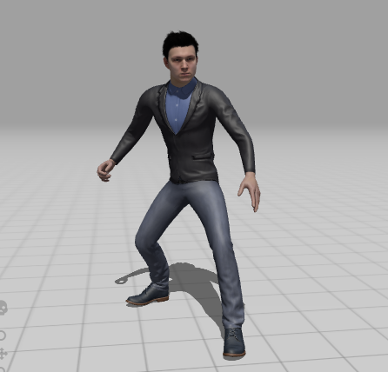

Drake – Enemy Creature Model

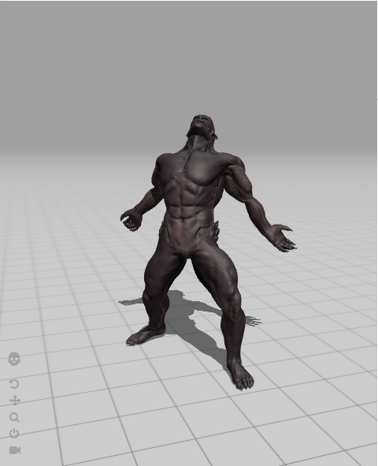

Door – Openable

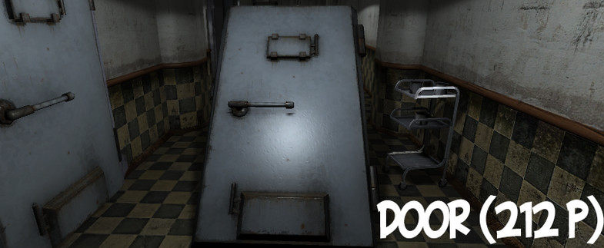

Bed

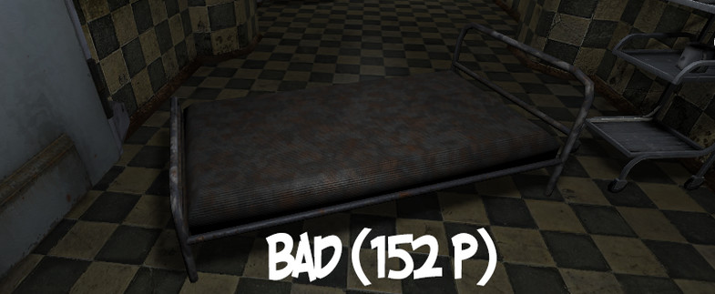

Light/Lamp?

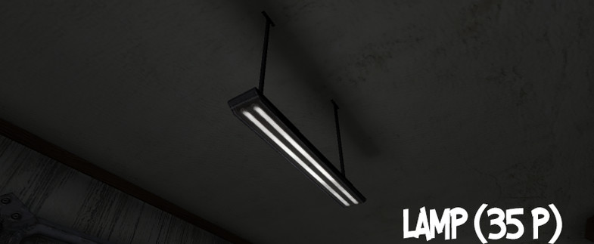

Stretcher – Player will be able to hide behind

